OpenCart Website Project for GIG Printing

**Free gift redemption**

1. Please write "Worth : <price>": ok

I thought we went through this before already.

Currently the price is without a "$" sign. Please add it in

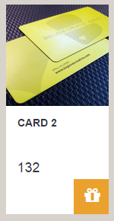

1. I added a test free gift on the backend but it did not appear in the front end: not range price: ok

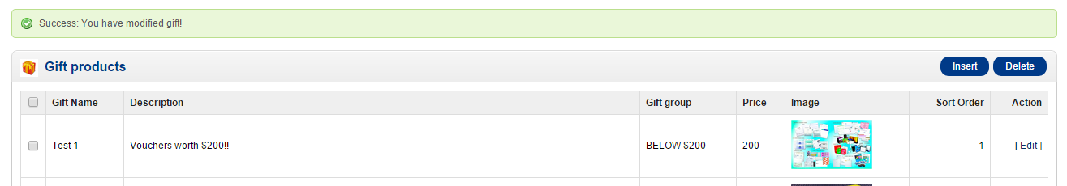

not appearing in frontend

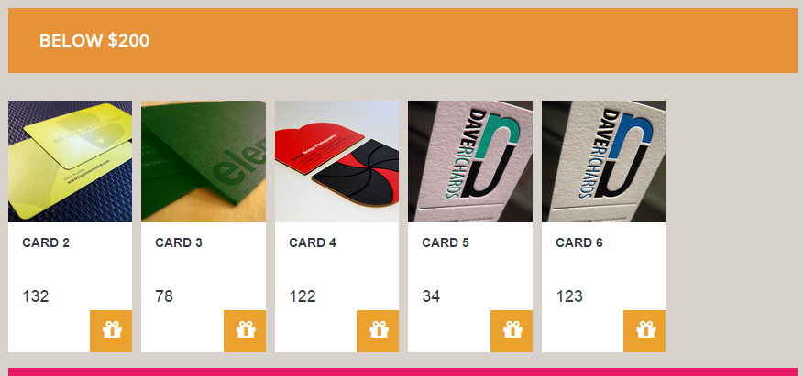

1. The name will be cut off if it is too long. So please state how many characters are allow, or just allow the whole name to appear.: 14 current

Backend



Frontend name cut off

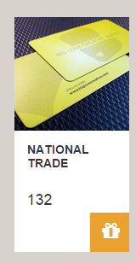

**Catelog Menus**

1. After you clear up previously, all the redundant menus are back again: ok

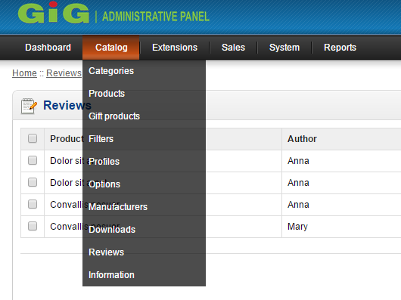

**Products**

1. Please remove unused functions from backend products.

There is not special price function for now. : go bo no di va tinh lai cong thuc gia: front + backend: ok

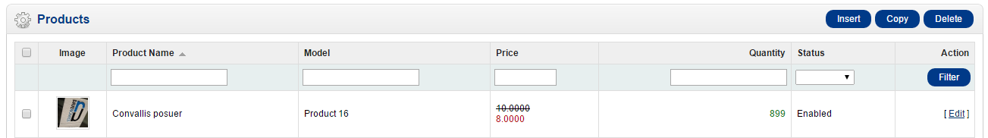

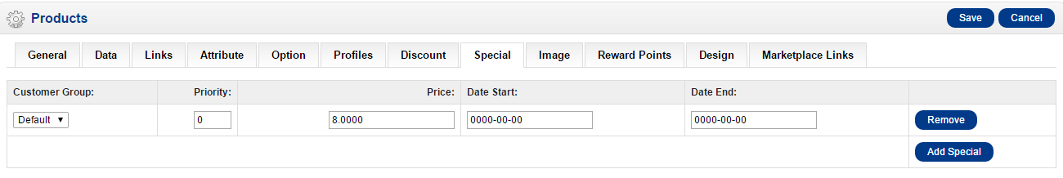

1. After check out, please change the sentence from "Please direct any questions you have to the Store Owner' to " Please contact us at GIG if you have any queries" and link GIG to the contact us page: ok

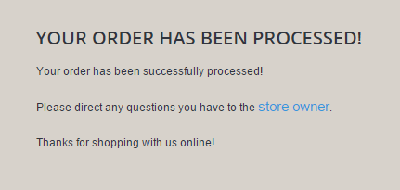

**Information**

1. The Page hang when I tried to create new Information Page: ok

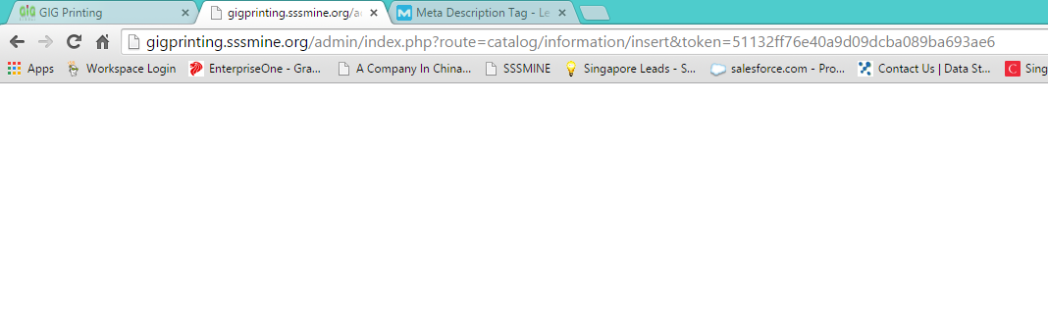

**Accounts**

1. Please remove this sentence from the account creation message : ok



**Homepage Banner**

1. After creating a new banner in the backend, it did not appear in the frontend: ok ( slider + banner advs)

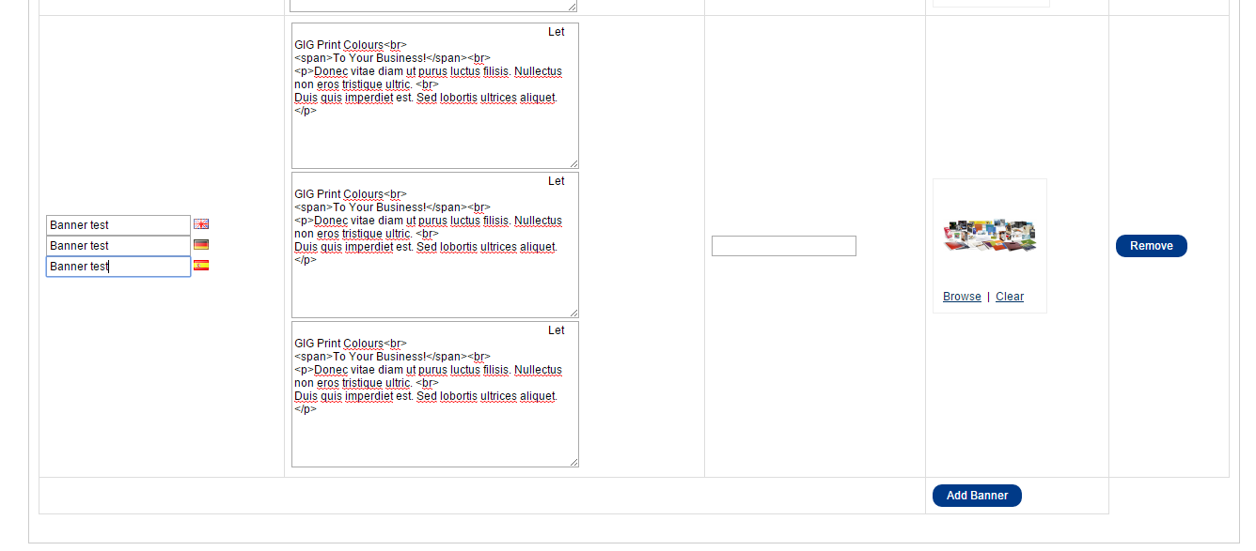

**Homepage Advertisement Products**

1. How do replace the dummy products and feature the real ones: Extensions -> Modules -> Featured -> Add, Delete, Change products.

